DmgCtrl, Ltd.
Repo.app Testing Guidelines

The Basics
This document assumes a functional knowledge of Git. You can find good information at http://git-scm.com/ or the book, Pro Git by Scott Chacon.
- Install the version of Repo.app that you’ll be testing on your computer. You can acquire the latest version at http://dmgctrl.com/repo/.
- Run Repo.
- You can “call” Repo (activate it) within applications, the Terminal, or from your Desktop by clicking <control> + <space> on your keyboard, by clicking the icon in your Dock, or by clicking the icon on your menu bar and choosing “Show Repo”.
- If you call Repo within certain programs (Xcode, Terminal, etc.), Repo will “recognize” if your working directory is related to a git repository, and it will display the related repository on its “command line” when you access it.
Test Repo’s Preferences
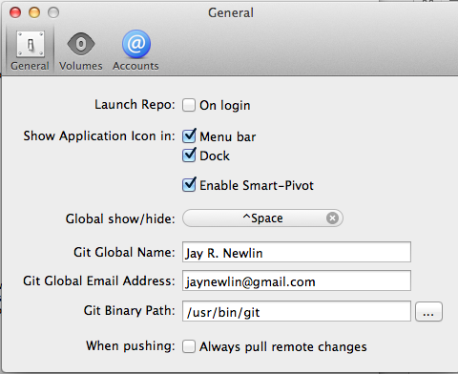
- Click the Repo icon in your menu bar and select “Preferences…”, or right-click the Repo icon in your Dock and select “Preferences…” (Be sure to test both methods of accessing the Preferences dialog, to insure that they both work.)
- Unselect (“turn off”) “Launch Repo: On login” in the “General” tab.
- Restart your computer, and make sure that Repo doesn’t start itself immediately.
- Reselect “Launch Repo: On login”, and restart again to insure that Repo starts properly during the login process.
- Test the operation of the “Show Application in” checkboxes:
  - Turn each choice off and back on in turn.
  - The Repo icon should disappear and reappear from the menu bar (at the top of your desktop) and/or the Dock (at the bottom of your desktop), based on the state of the checkbox.
- Test the “Global show/hide” (hotkey) option:
  - Click the “X” section of the button to delete the current hotkey. The button’s label should change to “Click to start recording”.
  - Click the button; the label should change to “Recording…”
  - On the keyboard, press the key-combination that you would like to become the new hotkey for repo.
  - Exit Repo’s Preferences dialog, and try to “call” Repo using your new key combination.
  - Click on the Repo icon in your menu bar, to insure that your key combination is shown as the “Show Repo” hotkey.
  - Try at least two different hotkeys, to insure that the functionality works with more than one different key combination.

Test the Functionality for New Repositories
- Test Repo’s init functionality:
  - Create a test directory and change to that directory.
  - Call Repo.
  - On the command line, type “init”.
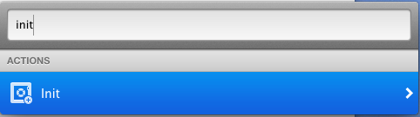
  - Double-click on Repo’s “Init” cell, or press the right arrow (on your keyboard).
  - After “Init” on the Repo command line, begin typing the name of the directory where you would like to store the new repository. Repo will suggest directories that match the pattern of letters that you type.
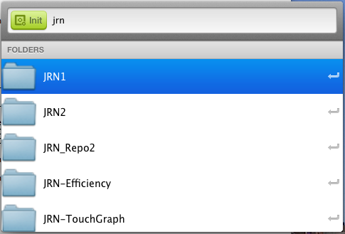
  - Double-click the directory where you would like the new repository to be initialized.
  - Repo will display a green checkmark on the “Init” cell, to indicate that it has finished creating the repository.
  - Use Terminal or Finder to insure that Repo created the appropriate files and directories for the new repository.
  - You can keep this directory/repository for other work that you might want/need to do, but be sure to use a different directory for the tests that follow.
- Test Repo’s clone functionality:
  - Start with a clean (empty) directory, not one used for previous git functions.
  - Clone the “Repo Testing” repository by calling Repo and typing “clone” in the “Type the name of a repository or command” field that appears. Double-click the “Clone…” bar that appears. 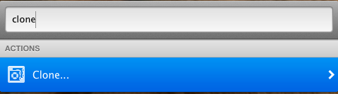
  - Type in the name of the remote repository to clone (or copy-and-paste it): git@github.com:JayNewlin/Repo_Testing.git
  - Press <return>.
  - Repo will open a Finder window for you to choose the directory to hold the repository clone. Choose a directory (folder), and choose “Open”.
  - Repo will clone the remote repository, and you should see a “Clone finished” Notification.
  - Use Terminal or Finder to insure that Repo created the appropriate files and directories for the cloned repository.
  - You can use this new directory and the clone of the repository for your further Repo tests.

Test “Day-to-Day” Functionality
- Create a new branch for your tests by choosing the “Branches” command, then choosing “Create Branch…” Name the branch with your initials, underscore, and a number. Press <return> after typing in the new branch name.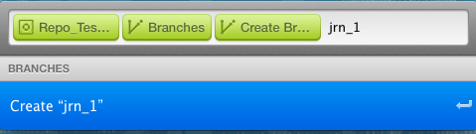
- Checkout the branch that you just created:
  - Choose “Branches,” then double-click on the name of the branch. 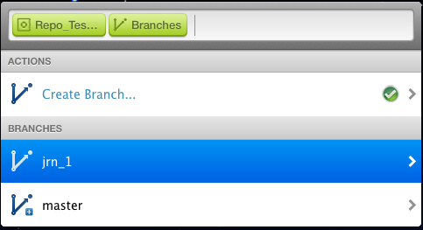
  - Press <return> or double-click to “Checkout.” A green checkbox indicates that the Checkout completed successfully. You will also receive a “Checkout Finished” notification.
- Add a new file to the project.
- Modify a project file.
- Use Repo’s “Status” command to insure that your added and modified files are listed. (Repo’s Status is the functional equivalent of git status at the command line.)
- Click on both files’ names to insure that a window showing the differences pops up to the right. (This window shows what has changed between the version of the file in the last commit and the version in your working directory.)
- Use Repo’s “Commit” command to commit your changes into your branch.
  - Be sure to click the checkbox individually for each file, or click the “Select All” checkbox.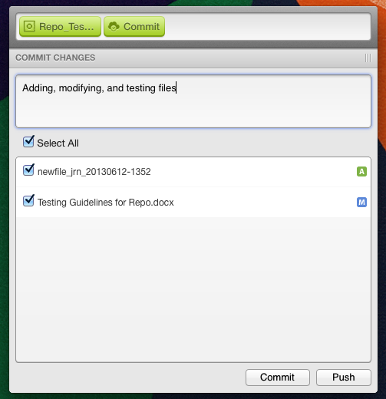
  - Be sure to enter a comment/message in the “Commit Changes” textbox. It is required for a commit in Repo.
  - Click the “Commit” button.
- “Tear off” the Commit window (by dragging the three bars toward the top right of the window – see the image below) and leave it sit, separated, for a while. Use the separated window to do some of the commits that are required later in this testing, to insure that the window continues to work properly.
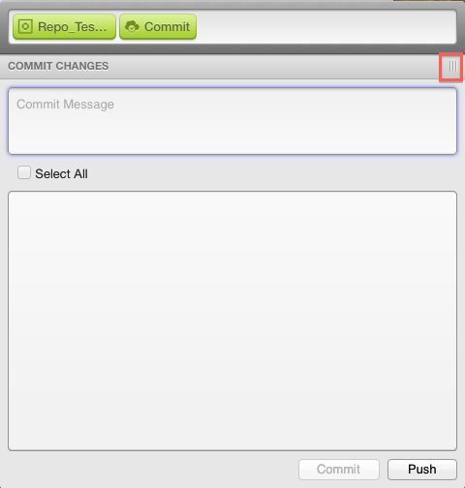
The torn-off window will look like this: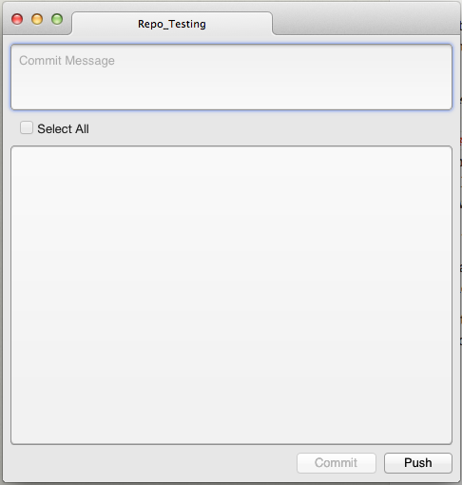
Note that all your changes should appear automatically in this torn-off window as you make them.
- Delete the file that you created earlier.
- Use Repo’s “Status” command to insure that the deleted file appears with a red “D” to indicate that it has been deleted.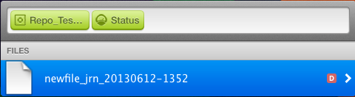
- Commit that change.
- Use Repo’s “Push” command to push your recent changes to the branch of the same name on your remote. 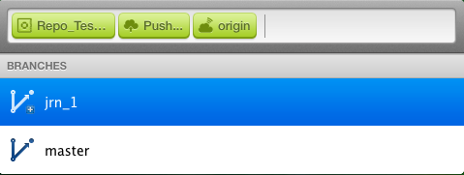
  - From the main Repo view, choose “Push…”
  - Double-click origin to send the push to your remote repository.
  - Double-click the name of your branch. Doing so is the equivalent of git push origin branch_name on the command line.

- A progress bar may appear next to “Push…” in Repo’s window during the Push process. You will receive a “Push… Finished” notification and see a green checkmark next to “Push…” if it was successful.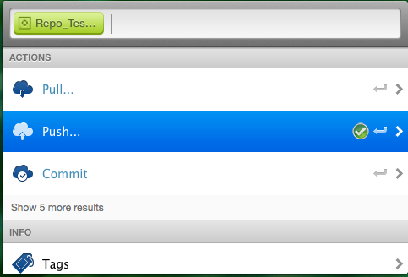
- Use Repo’s “Tags” command to “Create [a] Tag.” (This is the same functionality as the command git tag) Type the name of the tag after “Create Tag…” on Repo’s command line.
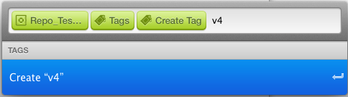
- You’ll receive a notification and see your Tag if the process was successful.
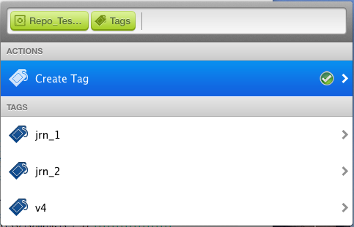
- Use Repo to checkout the master branch.
- Use Repo to fetch the information about your new, remote branch:
  - Choose “Fetch” from the main Repo view (You may need to choose “Show XX more results”.)
  - Choose “origin” under remotes, then “origin/master” in the list of remote branches. 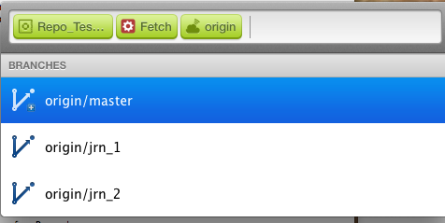
  - A progress bar may appear during the fetch process. You’ll receive a notification and see a green checkmark on-screen when the fetch completes.
- Use Repo to merge your branch into master:
  - Choose “Merge” from the main view.
  - Double-click on the branch to merge into master.
- Use the Commit tearoff window’s Push button to push your master to the remote.
- Use Repo to delete the branch(es) that you created:
  - Choose Branches from the main view.
  - Double-click on the branch you want to delete.
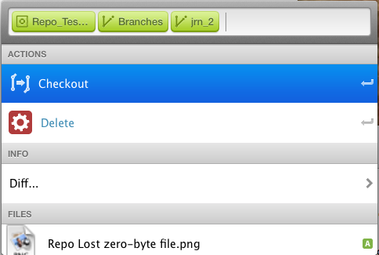
  - Double-click on “Delete.”
  - You should receive a notification that the “Delete finished”.
- Use Repo to create a new branch, and checkout that branch.
- Modify a file and commit the change in Repo.
- Use Repo to view the Diff between master and your current branch:
  - From the main view, choose “Branches.”
  - Choose the master branch.
  - Choose “Diff…”
  - Choose your current branch from the list of branches.
  - Modifications, additions, and deletions will be indicated. Click on a file to be shown the exact difference between master and the current branch. In the example below, text has been added to a file that is empty in master.
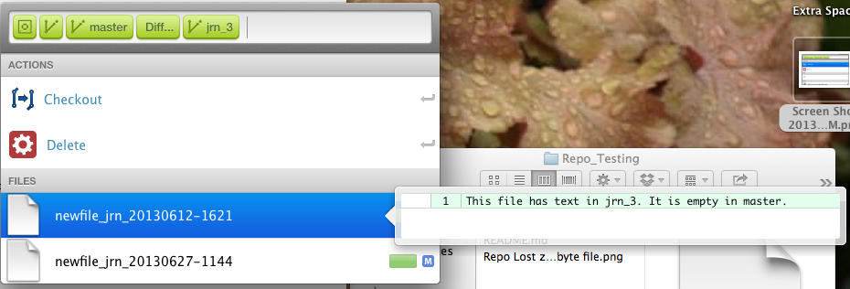
- Use Repo to discard changes:
  - Modify two of the files in your project directory.
  - Choose “Discard All Changes” on the main view.
  - Use Repo’s Status, the Terminal command line, or Finder to insure that the changes were “rolled back.”
- Review Repo’s “Log” to make sure that your recent changes are recorded.
- Search Repo’s Log for a keyword or portion of a word that you’ve used in your Commit Comments. In the Log (History) window, type the sequence of characters to search for in the “command line.”
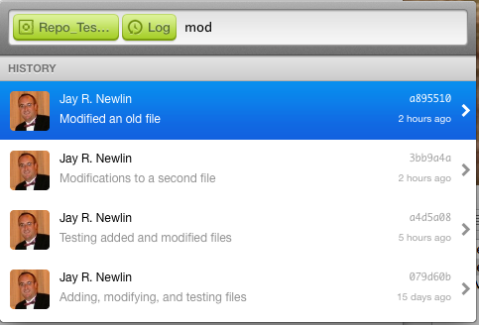

Test Repo’s “Special” Functions
- Use Repo to open an application:
  - Select “Open” from the main view.
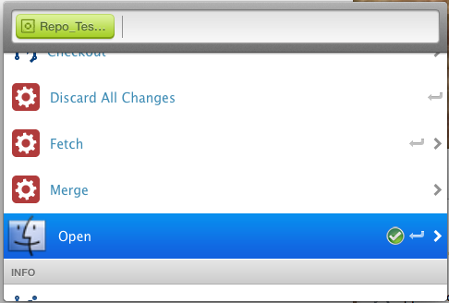
  - You will be presented with a list of applications on your computer:
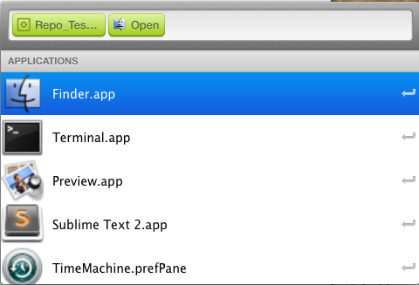
  - Choose one of the applications, and it should start.
- Use Repo’s Log (History) to checkout an “old” commit. Choose one of the Commits in your History, double-click on it, and double-click “Checkout.” Affirm with git status on the command line that you are “Not currently on any branch.” Review the files in your working directory, to insure that they are in the same state as they were when the commit was made.
- Be sure to checkout your “testing” branch before moving forward in your testing.
- Use Repo to reset your testing branch to a previous Commit:
  - Modify one of the files in your working directory.
  - Select one of the Commits from your Repo History (Log).
  - On the view that appears, double-click “Reset.” You should receive a “Reset finished” notification, and a green checkmark will appear on the Reset cell.
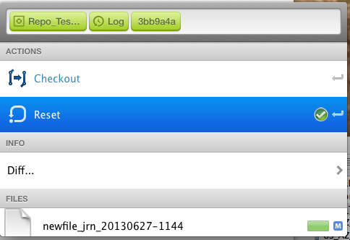
  - This is the equivalent of git reset –-mixed, so use git status to insure that the HEAD and the Index have been set back to the Commit that you chose. Double-check your recently modified file, to make sure that your working directory wasn’t affected by the reset.
  - Do not commit the reset/changed files, so that they are ready for the next test.
- Attempt a branch checkout using Repo. You should get “Checkout failed” notification and see a red exclamation point on the Checkout cell in the Repo view, since there are uncommitted changes.
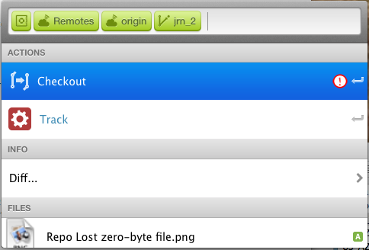
- If you haven’t pushed this branch to your remote, test that merging a local branch works properly.
- Try to delete your master branch:
  - Checkout master from Branches.
  - Go back through Branches to try to delete it.
  - You should receive a “Delete failed” notification and see a red exclamation point on the Delete cell.
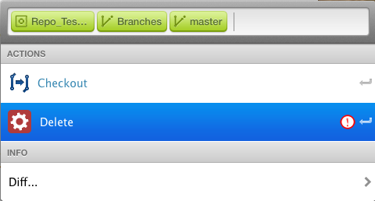
- Test Repo’s Stage and Stash functions:
  - If you need to, create a new branch and add or modify files.
  - Stage each file (which is the same functionality as git add or git rm at the command line) by choosing it from the main Repo view, then choosing Stage on the file’s view window.
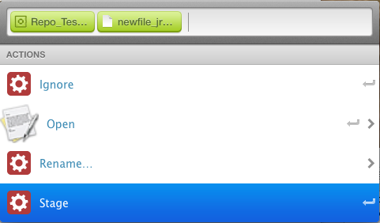
  - You should receive a “Stage finished” notification and a green checkmark on the “Stage” cell. (If your Commit tearoff is visible, you should see that the Staged file is marked with a check.)
  - NEED TO ADD STEPS TO TEST UNSTAGE
  - From the main view, select the Stash command.
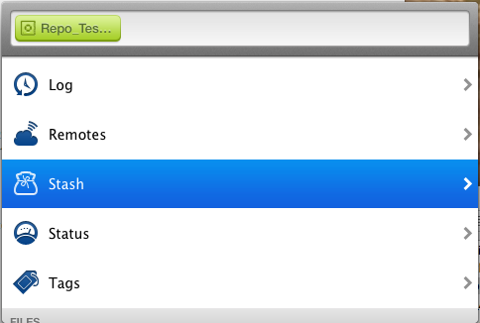
  - Stash will appear again as a choice. Double-click it.
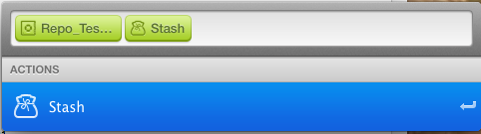
  - NEEDS TO BE FINISHED WITH SUCCESSFUL STASH NOTIFICATION AND GREEN CHECKMARK (IF IT APPEARS). (Be sure to note the effect on the Commit tear-off window.)
  - Switch to (Checkout) another branch, then back to your testing branch.
  - Apply the Stash to your branch (Repo main view – Stash – Select the Stash – Stash Apply). You should receive a “Stash Apply finished” notification and a green checkmark.
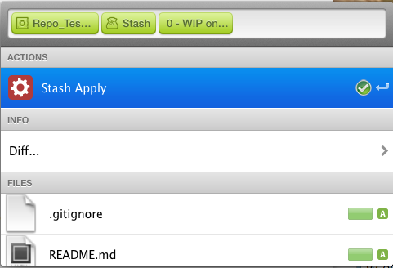
  - The files/changes should appear in the Commit tear-off window automatically.
- Test Repo’s “Ignore” function:
  - Create a new file to be ignored.
  - Select a file in the main view.
  - Double-click “Ignore.”
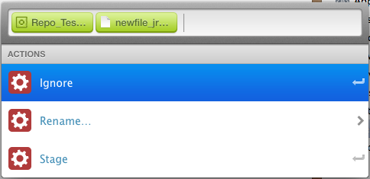
  - Verify in the file list views and the .gitignore that the file has been properly ignored.
- Use Repo to rename a file:
  - Select a file in the main view.
  - Double-click “Rename…”
  - Enter a new file name on the Repo command line and press <return>.
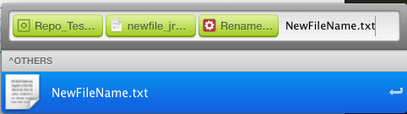
  - Insure that the new name appears in Repo file lists, in the filesystem (Finder window or Terminal), and on the Commit window.
- Test Repo’s “Open” command by selecting a few files and double-clicking on “Open.” Insure that the correct program opens the file. Test this on two or more file types/programs.
- Test Repo’s Commit window with multiple tabs:
  - Checkout a different project/repository.
  - Tear off a new tab of the Commit window for that repository, and add it to the Commit window that you already have open.
  - If necessary, make changes to files or add files in your “Repo testing” project/branch.
  - Use the Commit window to commit those changes.

